**SKU CODE: OL10**

**Oase Lunaqua 10 Light 12 V**

This light can be used as an externa light with 35W. 50W and 75W Halogen Lamps.

Beam Angle: 24*

Cable length: 2.5m, 5m and 7.5m

Transformer: 150W submersible transformer with 10m cable.

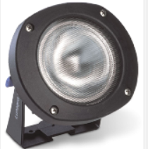

**SKU CODE: OL10T**

**Oase Lunaqua 10 Transformer**

**SKU CODE: OL10C5**

**Oase Lunaqua 10 Cable 5m**

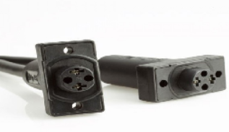**SKU CODE: OL10C7**

**Oase Lunaqua 10 Cable 7.5m**

**SKU CODE: OL10G3**

**Oase Lunaqua 10 Globe 35W**

**SKU CODE: OL10G7**

**Oase Lunaqua 10 Globe 75W**